DEMOCRATIC REPUBLIC OF CONGO
CHURCH OF CHRIST IN CONGO
20th Evangelical Community in Central Africa
AIDS AWARENESS PROGRAM
ADI OFFICE

P.O.BOX 143 BUNIA

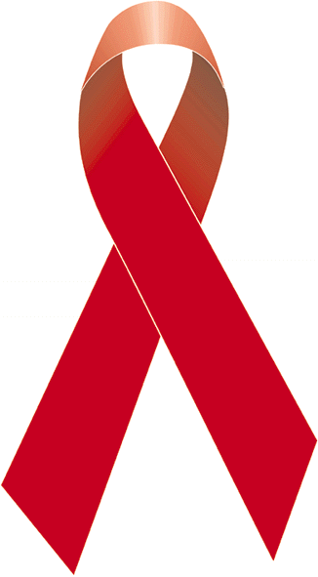

ANNUAL REPORT
2011-2012

Date of submission: 15 February 2013
Reporter: Annemarie Boks
Period of report: January 2011 – December 2012

Abbreviations
AAP: AIDS Awareness Program
AIDS: Acquired Immuno Deficiency Syndrome
AIM: Africa Inland Mission
ARV: Anti Retro Virals
CARM: Club d’Aide et de Réconfort Mutuel, Club of Help and Mutual Encouragement
CECA: Evangelical Community in Central Africa
DRC: Democratic Republic of Congo
HIV: Human Immunodeficiency Virus
HZ: Health Zone
IBF: Institut Biblique Francophone, French Bible Institute
IPASC: Pan African Institute of Community Health
ISPASC: Superior Pan African Institute of Community Health
ITM: Institut Technique Médicale, Technical Medical Institute – Nursing School
LRA: Lord’s Resistance Army
NGO: Non-Governmental Organization
OVC: Orphans and Vulnerable Children
PLWHA: People Living with HIV/AIDS
PNLS: Programme National de Lutte contre le SIDA, National AIDS Program
RTK: Radio Tangazeni Kristo, Radio to announce Christ
SAG: Support and Action Group
TBC: Tuberculosis
VCT: Voluntary Counseling and Testing
WAD: World AIDS Day
WGN: Women of the Good News

Summary
The AIDS Awareness Program (AAP) was established in 1999 in Bunia by the CECA 20 (Evangelical Community in Central Africa) after its leadership attended an AIDS conference in Kenya. The AAP has known development in its activities and is now based in Adi to work in four Health Zones, Adi, Adja, Ariwara and Aru. After having been provided with financial support from 2007-2010 AAP is without funding until now, except for small gifts of friends of the program. We like to thank them with all of our hearts for their faithfulness and we praise God that He has helped us to continue with the activities in the churches of the ministry area of CECA 20.

In this report we want to share with you the activities since the end of the funding period (beginning 2011) until the end of 2012. The expenses for those two years were: in 2011 $2.119,50 and in 2012 $4.754,67. We also would like to share with you our ideas for activities in 2013.

Our vision
Our vision for the AIDS Awareness Program is to establish in CECA 20 a complete structure to assure that all its members on all levels in the church are informed about HIV/AIDS to be able to assist others educating them or caring for them.

Our mission
Our mission corresponds with the general mission of CECA 20 to proclaim the Gospel and train disciples among the population of the Northeast of the DRC. The AIDS Awareness Program wants to mobilize members of the CECA 20 on all levels to be involved in the fight against AIDS to:
- Reduce the spread and the impact in the ministry area of CECA 20;
- Accompany PLWHA so that they’ll be able to accept themselves with their health status and to bring them to discover the eternal depth of the love and grace of God for each one of them, so that they will give glory to God the rest of their lives.

General objective
Create knowledge about AIDS among the members of CECA 20 and to mobilize them to answer to the challenge that this scourge presents to the church so to reduce its prevalence and impact in the ministry area of CECA 20.

Specific objectives
They focus on prevention, children and the youth, care for PLWHA and bilateral cooperation. The activities are to give necessary information about HIV/AIDS for all levels of the population, develop teaching materials, teach the youth who visit local night markets, stimulate VCT services and lobby for PLWHA (among others to have VCT and ARV treatment at the General Referral Hospital Adi).

Contact persons
- Miss Annemarie Boks
Director of AIDS Awareness Program, church districts CECA 20 Aru and Adi,
Adi DR Congo, P.O.Box 640, Arua Uganda
Tel. + 243 816310387 or +256 772904387
Email address: annemarieboks@gmail.com
- Revd. Kokole Idring’i Jean-Pierre
President and Legal Representative of the CECA 20
CECA 20 Bunia, P.O.Box 739, Entebbe Uganda
Tel. +243 812002758
Email address of CECA 20 office in Bunia: ceca20drc@gmail.com
- Oku-Onzi Dada
Vice-coordinator of the Medical Coordination CECA 20
CECA 20 Bunia, P.O.Box 739, Entebbe Uganda
Tel. +243 815314569
Email address: okuonzidada@gmail.com

Introduction
The Democratic Republic of Congo is a vast country of which the surface is almost as huge as all of Western Europe.

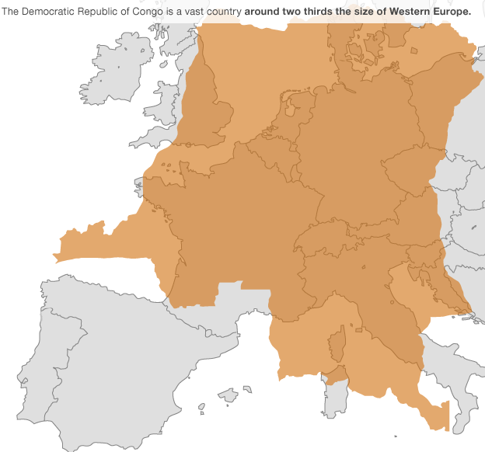
A big part is still forest and inhabited by man. In the East and North of the country rebel groups are active (M23 and others in North and South Kivu where Congo borders with Uganda and Rwanda and the LRA operates in the North in DRC, South Sudan and the Central African Republic). Nevertheless, in a big part of the country there is security.

The Church of Christ has its big ministry among the population. CECA 20 is one of the evangelical communities that work in the East of the country. Its area of action is from Goma in the East until the border with the Central African Republic. It has more than a million members. In its 100 years of existence it has created more than 950 primary and secondary schools and schools for further education. It manages more than 100 general hospitals, small hospitals and health centers. In each church section there are Bible schools and each church district has its Bible Institute. There are two French speaking Bible Institutes (in Aru and Banda) and CECA is involved in the direction of University Shalom in Bunia. The administration offices of CECA 20 are in Bunia. There are several departments and services (education, biblical training, medical coordination, the Women of the Good News, development, Radio Tangazeni Kristo… just to mention a few).

The AIDS Awareness Program (AAP in abbreviation) of CECA 20 (now under the direction of the medical coordination) started its ministry in 1999 after the church leaders attended an AIDS conference organized by AIC-Kenya. The coordinator of the education department was named as coordinator of the AIDS Awareness Program. He had easy access to schools and as member of the local church at Sukisa he started there to teach about AIDS. Following insecurity in Bunia at the end of 2002 he had to leave town and continued in Aru, in the Territory of Aru with the missionary who helped him since the beginning of 2002. In 2003, because of financial problems, he had to leave the program and the missionary continued the ministry. The program knew a growth in its activities: teaching at the Bible Institutes in the Northeast about AIDS using the manual: ‘Choosing Hope’; teach the population through broadcasts on RTK-Aru ; organizing video shows… The direction of the program knew two additions in personnel before the missionary left on home assignment in November 2005. She returned in May 2007. In the mean time the decision was made to localize the main office of the AIDS Awareness Program in Adi. From 2007-2010 the AIDS Awareness Program was financed by Red een Kind, an

organization in the Netherlands working for children. The team grew in number and also the activities multiplied. The AIDS Awareness Program started to work and develop activities in 4 Health Zones after being counseled to do so by Red een Kind and established a program in each of the Health Zones. An animator has been responsible to develop the activities. Support and Action Groups have been created (SAG – groups in the local churches that teach about AIDS and assist PLWHA). We participate in support groups for PLWHA (CARM – where PLWHA gather for mutual encouragement). We have translated ‘Choosing Hope’ in Lingala, produced a movie about AIDS, Along’hase, also in Lingala. We teach in communities, at schools, and in churches using debates, lessons and films. We also counsel and accompany PLWHA for VCT and treatment in Uganda, in Arua or Koboko.
Since January 2011 Red een Kind terminated the financial support of our AIDS Awareness Program in Aru/Adi and started to fund a project in the CECA 20 church district of Djugu, and this project also includes the medical and education department.
In the four Health Zones of Adi, Adja, Ariwara and Aru the animators did continue on a voluntary basis without salary. In spite of the lack of financial means they have been able to work with Support and Action Groups, with young people, with CARM and PLWHA, in primary and secondary schools, and in Bible Institutes and they have been broadcasting through Radio Savane Energie in Ingbokolo.

Geographical information of the four Health Zones
The four Health Zones in our area of ministry, Adi, Adja, Ariwara and Aru are situated in the Northeast of the Democratic Republic of Congo in the Territory of Aru and the Ituri Region. Adi, which is in the north of the country, has its borders with South Sudan and Uganda; Ariwara and Aru (in the south) are bordering Uganda, while Adja is in the interior of the country. The region is characterized by savanna. In all the HZ there is agriculture and cattle/goat breeding. Security is sometimes perturbed with gunshots. There are bandits and rebels who bother particularly during the night. The gunshots scare the population who leave their houses to flee. The last months of 2012 know more insecurity in the county of Kakwa (HZ Adi).

Demographical information
For the four Health Zones the demographical numbers are the following:

 | Total Population | Children 0-59 months | Children 5-15 years old | Women in procreation age | Pregnant women
4 HZ | 616.630 | 116.543 | 179.438 | 129.492 | 24.665
Adi | 148.812 | 28.125 | 43.304 | 31.251 | 5952
Adja | 116.273 | 21.976 | 33.835 | 24.417 | 4651
Ariwara | 184.895 | 34.945 | 53.804 | 38.828 | 7396
Aru | 166.650 | 31.497 | 48.495 | 34.996 | 6666

Activities of the population
The population lives of agriculture (beans, peanuts, manioc, bananas, sweet potatoes, sorghum, rice and so forth), of which the products are often sold on the market by the women to have a small amount of money for domestic use; and breeding of cattle, goats, sheep and chickens/ducks, while there are traders and intellectuals who work in medical services, education, and in some NGO.
Tobacco is a big cash crop in Adi, Adja and Ariwara, and this causes often problems in the family. The man of the family uses the money for his own needs and distractions (often alcoholic beverages with his friends) while it was his wife who did most of the work. Other cash crops are: peanuts, rice, firewood, charcoal, and planks. Commercial products that are available on the market are often imported from Uganda and include cloth, clothes, shoes, beauty articles like soap and lotions, kitchen articles, sugar, powdered milk, salt, bread and so forth, but also alcoholic beverages that have a high percentage of alcohol in it like vodka, whisky and those are sold in small plastic bags or in small bottles.
In the four HZ there is a total of 57 towns/commercial centers and 515 villages.
Ariwara is the biggest commercial center with a big market where many products are found. Next to garden products there are clothes and other industrial products. It is easy to import these articles from Uganda and even from Dubai, as there is a border post close to Ariwara.

One of the problems that we find especially in the commercial centers is the presence of night markets (that can be compared to open air discos), the cinemas and the bars that attract many young people. Cinemas even attract kids, while the movies are not at their level. In the HZ Adi there are 34 night markets and 16 cinemas. The only bar is in Ingbokolo where men are attracted by a game of pool. In HZ Adja there are 15 night markets, 8 cinemas and 4 bars. In HZ Ariwara activities of distraction are the night markets, of which there are 30. There are 45 cinemas and 10 bars. In HZ Aru there are 31 night markets, 39 cinemas and 14 bars. Other activities of distraction are card plays, soccer (loved by all) and Parcheesi (a board game where the peons need to walk around and finally brought home by throwing the dice). However, young Christians also are occupied by religious activities like choirs, spiritual retreats, and services for the youth, musical nights, concerts, and debates. Men also engage in hunting and fishing during the dry season. Children have periodic games and adults also like to take walks.

Religious life
CECA 20 is one of the biggest evangelical churches in the DRC and has more than 1 millions members. In our four HZ there are also Anglican, Catholic and independent churches. Also Islam is to be found.

In our HZ there are
- 376 local churches of CECA 20, 69 groups of the Women of the Good News, 89 licensed pastors and 226 reverends,
- 79 Anglican churches, 8 licensed pastors and 9 reverends,
- 156 Catholic churches, 81 licensed pastors and 14 reverends,
- 14 independent churches, 16 licensed pastors, 1 reverend,
- 6 mosques and 1 imam.

The women of CECA 20 come together in their ministry groups, called Women of the Good News. They have their Bible studies every week, conferences, they make home visits to mourning families or those in problems, those who deal with illnesses…In many local churches there is a group of the WGN.

The AIDS Awareness Program has started the creation of so-called Support and Action Groups in the church sections and local churches. There are now 21 groups and 16 are functioning well. Church members working as volunteers teach about AIDS in their community and they assist PLWHA.

In our area of ministry in the 4 HZ there are 10 Bible schools of which 9 use the manual ‘Choosing Hope’ to teach future pastors about AIDS.

Education
As already mentioned, CECA 20 has created more than 950 primary and secondary schools and schools of higher education in all of the region of ministry. The CECA 20 schools in our HZ are: 125 primary schools and 52 secondary school and 2 schools of nursing (ITM in Ariwara and Adi). In our four health zones there is a total of 422 primary schools, 151 secondary schools and 6 schools of higher education. One school of nursing is in Aru. In 127 of those schools the manual ‘Attention AIDS’ is being used.

A big problem perceived in our four HZ is the number of orphans and vulnerable children (OVC) and children who don’t attend school. In total the animators have estimated that there are around 11.000 OVC in our region, of whom one-third due to AIDS. Among the OVC half of them go to school (some of which are supported by our program). The total number of children who don’t attend school is estimated around 17.500.

Medical services
In our four HZ there are 7 general and small hospitals; 105 Health Centers or Health Posts; 25 medical doctors, 801 nurses. There are three schools of nursing (two of CECA 20 in Ariwara and Adi and one of the government in Aru) where nurses are trained to function at A2 level.
Frequent diseases are: malaria, typhoid fever, upper respiratory infections, intestinal worms, diarrhea, amibiasis, onchocercosis, anemia, SIDA, sexually transmitted diseases, diabetes, hypertension and malnutrition.
The prevalence rate of malaria is between 35-40% and of TBC 0,5-1%. The prevalence rate of AIDS according to IPASC (Pan African Institute of Community Health) is 6%.

AIDS
It is estimated by IPASC that the prevalence rate of AIDS is 6%. However, following the taboo and shame that figure could be higher. In spite of the stigma going down, there are still many PLWHA who are not open about their health status because they are afraid of being marginalized in society. Proof of this is that only 21% of known PLWHA in our four HZ participate in the different support groups (CARM), where PLWHA find mutual encouragement.

The total of PLWHA known in the 4 HZ: 2.567.
Adi: 718; those who participate in CARM are 206 (28,7%).
Adja: 55; those who participate in CARM are 35 (63,6%).
Ariwara: 971; those who participate in CARM are 204 (21%).
Aru: 823; those who participate in CARM are 96(11,6%).

The majority of PLWHA are under treatment with ARV. Unfortunately, treatment programs do not yet exist in our HZ except in Aru where treatment is organized in the State General Referral Hospital. The majority of PLWHA are following their treatment in Uganda, either in Arua or Koboko, which demands a lot of time and money for transport and immigration, accommodation and meals in Uganda. The General Referral Hospital in Adi is on the list of the government and the National AIDS Program (PNLS) to organize treatment for PLWHA. But before this can take place the National AIDS Program demands a training given by them of the medical staff and this training is expensive. However, it is essential that this training takes place in 2013.

Many of the people who think they might be infected do not dare to go for testing. They try indigenous treatment before thinking about going to talk to a person who could give counsel. Sometimes it is too late and they die before going for testing and there is only a speculation that it was AIDS that was the underlying problem that killed the person.

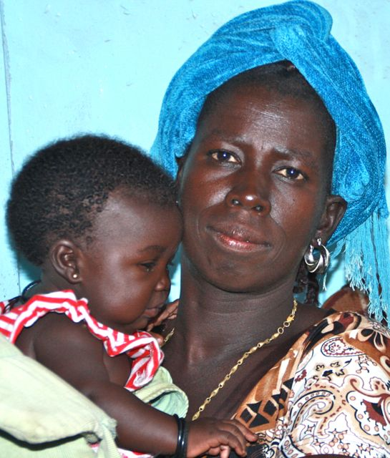
Testimony of a woman living with AIDS
I have to go to Arua every month for treatment. It is that often because I have a daughter of one-year-old now. In rainy season the trip can take up to 6-7 hours (for about 80 km) because of the bad road conditions. Sometimes we have to stay on the veranda of the parking to wait for an occasion to return to Congo. The costs are high, first for the transport to Arua and back, immigration, accommodation, and meals in Arua. My daughter cries a lot while traveling. I wish, and with me many other persons who live with the HIV virus, that our treatment can be organized in Adi.

AIDS Awareness Program CECA 20
From 2007 till 2010 the AIDS Awareness Program was funded by Red een Kind, a Christian NGO from The Netherlands. The financial support was terminated after the four-year contract was finished. This termination was difficult for the team of the AIDS Awareness Program because already hopes were raised for a continuation of the funding and the planning for 2011-2015 was already in the process of being written. We had to fire the staff and some have found other employment but others have continued the ministry on a voluntary basis without a salary. Even during this meager period they have developed the activities to bring growth to the program, for which I am thoroughly grateful.

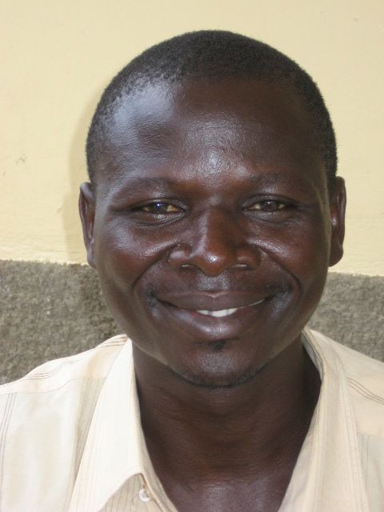
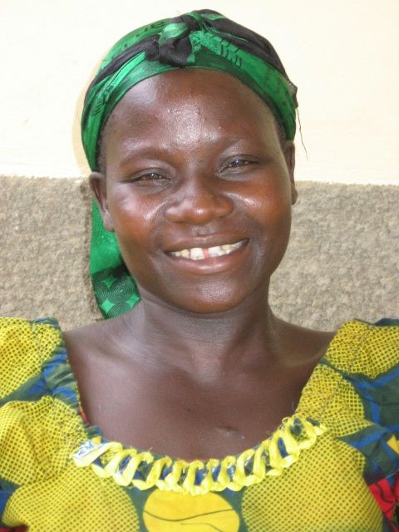
Okusaru Agabho and Alio Avudri work in the Health Zone of Aru. Okusaru started to work for the AIDS Awareness Program in February 2005 and Alio in July 2007 (when Okusaru was on maternity leave). Both are qualified at ISPASC in Information, Education and Communication for their work and are concerned that the ministry goes forward and develops.

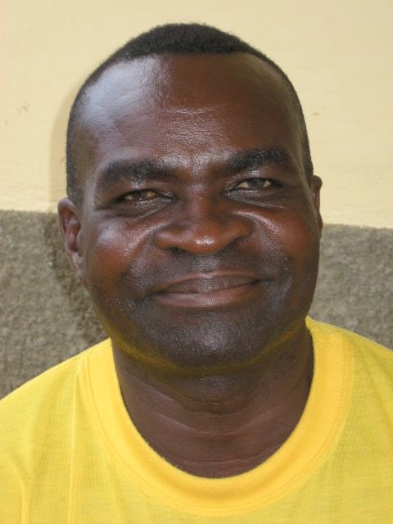
Bhayo Leku is a reverend and he started working for the AIDS Awareness Program when there was a demand during the years 2003-2005 and strengthened the team full time in 2008. He is the animator for the Health Zone of Ariwara and lives in Abedju, a border village. He is a compassionate man, which shows itself in his availability to accompany people to Arua or Koboko to get tested and his abilities in counseling. He created CARM Abedju, and also started a group of young warriors for Christ in Abedju and thirdly he assists the other animators with the creation of SAG.

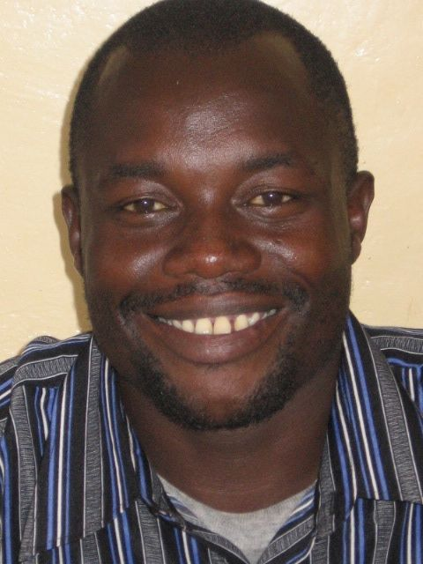
Likambo Mutro works as the animator of the HZ Adi since 2008. He organizes the broadcasts at the Radio Savane Energie every week. He also assists people to go to Koboko to get tested. He is involved in a child rescue center of orphans called Bethsaida in Ingbokolo, the town in the HZ. During his ministry in the HZ he is much demanded for counseling PLWHA. His training is in education.

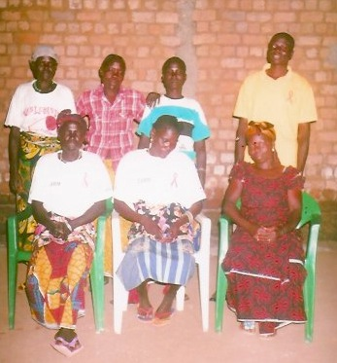
Ayikoyo Alidra (on the photo standing right) is the youngest in the AIDS Awareness Program that he joined in 2010. He works in the HZ Adja. He created two SAG/CARM (Adja and Atsinia) with the help of Bhayo. He studied at ISPASC and has graduated in management. For the very first time World AIDS Day, organized by the AIDS Awareness Problem, was memorized in Adja on the first of December 2012.

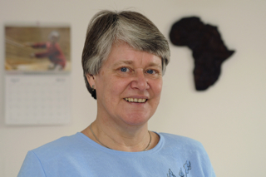
Annemarie Boks is a missionary with the Africa Inland Mission (AIM) and she works with the AIDS Awareness Program since 2002. She coordinates the work in the four HZ. She is originally a nurse and has a Master’s Degree in Community Health.

The activities realized in 2011-2012

The activities realized in 2011
- Teaching at the Bible institutes: IBF Aru (women’s section) and EBS Adi;
- SAG: creation of SAG in Adi, Leiko Rumu, Modo, Adja;
- Follow-up and strengthening of functional SAG;
- Distribution of books: ‘Choosing Hope’ (French and Lingala – for the Bible institutes and pastors) and ‘Attention AIDS’ – for primary and secondary schools)
- Broadcasts on the Radio Savane Energie Ingbokolo;
- CARM Abedju and Ariwara;
- Youth Camps (Scripture Union) HZ Adi and Ariwara;
- Support for school fees of Orphans and Vulnerable Children;
- Vocational school in Abedju for the young warriors for Christ, youth who have left school but now want to continue to study;
- Medicinal garden;
- Gardens to help PLWHA and OVC;
- Creating awareness in villages through films, debates and teaching;
- Training of hospital personnel in Abedju on counseling;
- Counseling, home visits to PLWHA and OVC, accompany people to Uganda for VCT and treatment with ARV.

Activities in 2012
- The teaching at IBF and EBS has continued;
- Home visits to PLWHA and OVC;
- Youth Camps of Scripture Union in Kumbuku and Kumudhu in the HZ Aru;
- Creation SAG Kumbuku, Kumudhu, Lio, Atsinia;
- Follow-up and strengthening of functional SAG;
- Broadcasts on Radio Savane Energie (except in January when there were problems with the electricity and from October-December following looting);
- Counseling and accompaniment of PLWHA for treatment in Koboko; unfortunately there were 2 deaths among them this year;
- To accompany people to go for testing;
- The vocational school in Abedju continued for the young warriors;
- Creating awareness through films;
- Medicinal garden;
- Spiritual retreats;
- Reunion for girls who are mothers in Abedju;
- Census in September-November 2012;
- Gardens for PLWHA and OVC;
- WAD with other forces in the fight against AIDS;
- Visit to the church district of Watsa; here there are many gold mines, which results in adultery, alcoholism, and drug use that lead to infection by HIV. The local churches ask how they can answer the problems and teach about these dangers.

Finances 2011-2012

Expenses AAP
2011-2012
Activities | 2011 | 2012 | Total per activity
Fuel | $50,00 | $189,80 | $239,80
Film and creating awareness | $31,00 | $146,60 | $177,60
Office | $28,50 | $89,12 | $117,62
Maintenance motorbike | $59,00 | $128,08 | $187,08
Gardens |  | $142,00 | $142,00
Census |  | $65,04 | $65,04
OVC |  | $20,00 | $20,00
School fees |  | $93,44 | $93,44
Home visits to PLWHA and OVC | $100,00 | $57,20 | $157,20
WAD |  | $223,60 | $223,60
Retreats |  | $25,76 | $25,76
SAG | $437,00 | $169,12 | $606,12
Accompany PLWHA to Koboko |  | $26,56 | $26,56
Training of SAG |  | $1,60 | $1,60
Medicinal garden |  | $49,60 | $49,60
Girl-mothers |  | $12,00 | $12,00
Young warriors for Christ | $200,00 | $60,60 | $260,60
CARM | $50,00 | $38,00 | $88,00
Chaplains’ reunion |  | $4,00 | $4,00
Creation of SAG | $950,00 | $44,00 | $994,00
Motorbike |  | $650,00 | $650,00
Training | $82,00 | $4,56 | $86,56
Advantages for animators | $132,00 | $1.040,95 | $1.172,95
Book EBS |  | $100,00 | $100,00
Attention SIDA |  | $300,00 | $300,00 | Debt $700
Reunions AAP |  | $212,04 | $212,04
Documents motorbike |  | $261,00 | $261,00
Reimburse debts 2011 |  | $600,00 | $600,00
Total | $2.119,50 | $4.754,67 | $6.874,17
Entrance into the cashbox of each HZ | 1st amount | 2nd amount | WAD | Total
Adi | $700,00 | $75,00 | $50,00 | $825,00
Adja | $300,00 | $75,00 | $50,00 | $425,00
Ariwara | $300,00 | $75,00 | $50,00 | $425,00
Aru | $300,00 | $75,00 | $50,00 | $425,00
 |  |  |  | $2.100,00

Barriers and difficulties
The AIDS Awareness Program works under the power of God but barriers and difficulties never lack in the work of God. There are a couple.

- Until now the AIDS Awareness Program lacks donors to fund one or more activities, the advantages of the animators and the means of transport.
- Lack of office space in the four HZ.
- Lack of transport – the animators borrow light motorbikes of their relatives, except in Adi.
- There is a lack of films in the local languages, such as Lingala, Kakwa and Lugbara.
- In spite of the General Referral Hospital of Adi is on the list of the National AIDS Program to treat PLWHA by ARV, to do VCT and PMTCT, this is not yet realized because the National AIDS Program demands to train the involved personnel and this training is expensive.
- Following this there is a lack of assistance of PLWHA and OVC and a lack of follow-up.
- Since a couple of month there is more insecurity in our region, especially in the HZ Adi that influences also the possibilities of working well. It especially touches the video shows during the evenings as is it advised against traveling by evening or at night.
- In October there was looting in Ingbokolo and the equipment of Radio Savane Energie was also looted which interrupted broadcasts for about two and a half months.
- Only two of our HZ have a kit for projection. If another HZ wants to borrow it transport is difficult as we only have light motorbikes for the transport.

Challenges
The biggest challenge we face is the lack of money and the need to search for financial assistance. The animators also face many challenges in their ministry, because, how do they care for their families? Another challenge is to be wise in the planning of the activities as to have the biggest impact possible while using small means and particularly in a region that knows insecurity now.

Perspectives for the future
We want to involve the church leaders in the fight against AIDS, as well as PLWHA themselves. We know several who are already involved and they can be integrated even more in the ministry. One example is a woman living with AIDS who has studied at the section Bible school in Abedju and who is now chaplain of CARM, the support group for PLWHA. She is gifted in compassion and mercy. In Leiko Rumu a nurse who is HIV positive takes care for and counsels other PLWHA.

The vocational school in Abedju also gives a perspective to integrate young people in the fight against AIDS. With an education that is adapted they will be the best teachers of their peers.

It is also necessary that the SAG have their own income generating projects to earn money that they can use to help PLWHA. There are already several SAG that have started with gardens (Abedju, Adja and Lio) or with chicken raising. Abedju has also bought a cow and goats. In Abedju there is also a garden with medicinal plants to strengthen the force of PLWHA and protection against opportunistic infections.

OVC also need special attention. There are OVC who were helped in earlier years and three of them have obtained their state diploma for secondary school. While others have moved a class higher or have started secondary school. In Aru the animators have organized a meeting with the OVC there in 2012. We wish to have funds to help the most deprived and vulnerable amongst them so that their future shows the light of possibilities.

We also wish to raise the number of radio broadcasts, and also introduce local languages like Kakwa and Lugbara because people from Uganda and South Sudan are listening too.
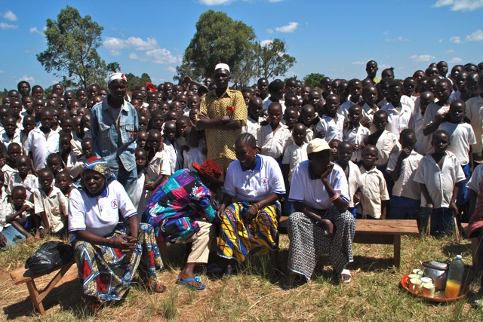
We must do our very best to fight this disease AIDS that has become an object to laugh about for the youth today.

The fight against HIV/AIDS needs unity and a good collaboration in which we work hand in hand.

(2 quotations from the report of Aru HZ)

Photo : JMLS Drobokolo, ZS Adi, 2012

Subjects of praise
- God, the Almighty, is the Master of this ministry of the AIDS Awareness Program;
- The work continues, in spite of multiple difficulties;
- God protects us in spite of insecurity;
- The animators give themselves for the work and to assist PLWHA;
- Several PLWHA are involved in the ministry;
- Three OVC have received their state diploma for the secondary school;
- Young people give themselves to study at the vocational school and we also give praise for their teachers.

Subjects for prayer
- The search for financial support for the AIDS Awareness Program or one or more of its activities;
- Financial support for the training of the personnel of Adi General Referral Hospital so that the treatment can be done at the hospital;
- That security might be reestablished in the region.

The planning for 2013

Talks are going on about the planning of 2013 and here are some of the activities we hope to develop in 2013:

- Lobby for and organize the training of the National AIDS Program so that Adi General Referral Hospital can start treating PLWHA;
- Create new SAG in the four HZ;
- Outreach in the church district of Watsa with creation of SAG;
- Creation of SAG in Kisangani;
- Develop teaching materials;
- Production of a sequel to the movie Along’hase;
- Production of a movie about a Christian marriage;
- Vocational school in Abedju;
- Radio broadcasts (in Aru, Ariwara and Ingbokolo);
- Organize video shows;
- Teaching at schools;
- Print and distribute the module ‘Attention SIDA’ in schools;
- Organize activities for and with OVC and PLWHA;
- Production of lesson books in Lingala (for the Bible Schools, for the Women of the Good News, for young couples);
- Organize activities of CARM;
- Be involved in the organization of World AIDS Day and participate in the activities in the four HZ
- Meetings with medical, church, civil authorities…;

Necessary finances:
- For all the activities;
- Means of transport (four Yamaha motorbikes)
- Four digital cameras;
- Advantages for the animators;
- Capacity building;
- Fuel;
- Office equipment…

Annex 1
The map of the DRC with the Ituri Region. The Territory of Aru is in the Northeast of the region.

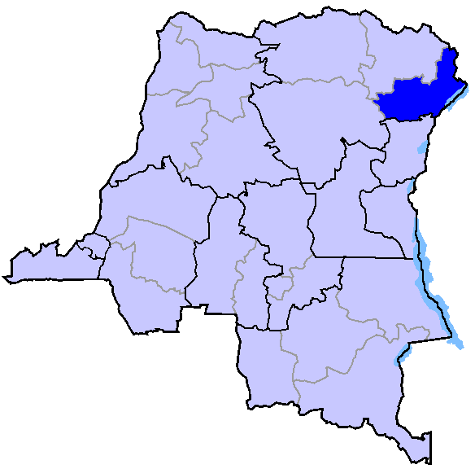

http://www.bbc.co.uk/news/world-africa-15722799
See the map in annex 1
Selon l’information du District Médical Aru pour 2012

